**Analysis of Best Practices**

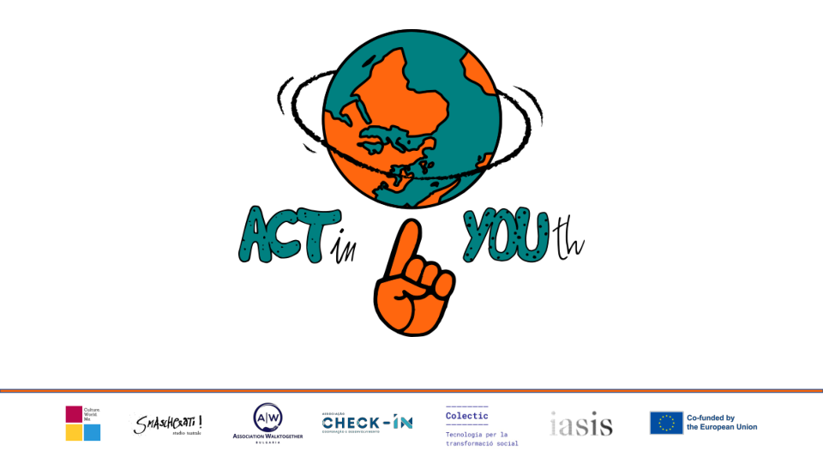

All countries participating in the project agree that increasing cultural diversity within the global community requires youth professionals to know and understand the diverse values, customs and traditions of young people and to help create inclusive intercultural experiences. for all of them. The influx of emigrants, refugees and European migrants to Europe, along with the need to effectively integrate the different ethnic groups of the national nations on the continent in the education system, social environment and labour market create the preconditions for seeking new approaches to sustainable development. multicultural understanding, dialogue and cooperation.

When we talk about social inclusion, we certainly mean a multidimensional process. In other words: inclusion implies a certain period of time, cumulative interconnected situations, exposure to more or less systematic models of socialization. Thus, we can say that there is inclusion when someone has economic, but also cultural, social, political and symbolic resources capable of providing a state and a sense of belonging to a whole, be it a group, social class, institution, organization or country. Thinking of inclusion within a system of inequalities, this intersects inequalities in social classes with other types of inequalities that are essentially as important as those of ethnic origin, gender and sexual orientation. These inequalities interact with each other depending on the individual's relationships, historical moments and life cycles of individual pathways. If we look at the connection between the performing arts and social inclusion, this basically enables each individual to gain access to learning environments through art in order to integrate into their community, regardless of their economic difficulties, social class, ethnicity, religion, linguistic and cultural heritage or gender.

In Portugal, the concept of non-formal education and the creation of communities of artistic practice is increasingly seen in relation to programs that take place outside the formal education system, as extracurricular activities specifically targeted at populations considered at risk. With regard to young people, we are talking about countless Portuguese in situations of greater social instability, such as unemployment, dropping out of school, delicate family situations or young people in institutions. All 5 good practices related to artistic expression, explained in this document, are indisputable examples of how several social projects dedicated to the empowerment of young people can be found in society. The Portuguese community is diverse in terms of cultural background and identity, but such a heterogeneous society can come together and see many of its differences fade, either with an opera in a random prison in Leiria or with arts learned and performed in a social neighbourhood in Leiria, Sintra. For a project like this, the best practices that the team says best meet its goals are theatre classes as extracurricular activities after school and the role of theatre as a mean of preventing students from failing and dropping out of school.

Such activities are 100% related only to the theatre as present in the fight against social discrimination and a certain empowerment of young people at risk. However, according to the personal experience of one of the team members, the tradition of academic “tuna“ as a safe haven for students, displaced and in trouble with the transition to adult life, is the best example of a practice that exists only in Portugal (although Spain also has its own tuna), which helps empower these students. They become more confident with their performances on stage, and the hierarchical system typical of such an organism undoubtedly makes the young person more respected and with better self-confidence. And of course: all these practices are also a great way to promote lasting friendships!

A specific element in the practices proposed by Portugal is the Ópera na prisão Project, implemented in the period 2003-2021 by the Calust Gulbenkian Foundation in Lisbon and Leiria Prison, Portugal. The project is aimed at young prisoners and the power of opera as a way to combat criminal recidivism. It aims to use art as a tool for integration as prisoners sing on their way to freedom. Professional artists from the world of classical music and young prisoners meet regularly in prison to exchange artistic experience and organize an opera performance. For cycles of 3 years, an opera is being prepared to be performed by prisoners, prison staff, technicians, wardens and family members. An orchestra and professional opera singers, as well as a maestro, are also involved in this project. Another practice is aimed at teenagers between the ages of 15 and 18 and young adults between the ages of 18 and 24. It is intended for young people who are neither in the labour market nor in the formal education system, or for young people at risk of dropping out of the education system. Other practices are oriented towards pupils and students and the possibilities of theatre in school activities as a substitute for other subjects, upgrading the knowledge and skills of students after school through an interactive artistic approach to dramatic expression. In this aspect, the practices are close to those proposed by Bulgaria, which are entirely oriented towards the application of theatrical methodologies and artistic approaches in classroom and extracurricular activities. The activities are implemented entirely in school education and use the opportunities of the performing arts to develop skills, tolerance, acceptance, expression and personal growth.

The closeness of the proposed practices from Italy and Greece is logical. The target group of "young people from different backgrounds" is very diverse: asylum seekers, refugees, young second-generation migrants. Italy is a borderland located between Africa and Europe. The practices proposed by Italy represent associations that work with young people from different backgrounds through theatrical practice. The selected associations that work with the target group work mainly with theatre. In one case, due to its peculiarity and specific interest, we opened Onlus, which does not work specifically with theatre, but uses it in practice as a means of expression. The workshops are open to all and are free to enable even disadvantaged people to take part in the activities. The seminars are held in Italian, French, English. Depending on the composition of the group there are also Chinese, Urdu, Arabic. Each year, the seminars lead to final original theatrical performances, characterized by the richness that the different cultures of the participants bring with them. The seminars consist of three parts: the first focuses on knowing the other, the space, the rhythm, through a preliminary improvisational game; the second is dedicated to the clown: the red nose is the smallest mask in the world and, unlike the others, does not hide, but rather illuminates the actor's face. Putting on a red nose means starting a search within yourself, for your most hidden part, the one you would never want to expose, the one you are even ashamed of, the most fragile and ridiculous part of ourselves. The search for simplicity and immediacy, a modest attitude towards one's own role, openness to the audience (who are real interlocutors) are principles that must always be addressed by those who do theatre. There is therefore great pedagogical value in this study and it is essential for the training of an actor, even for those who will never do a show with a red nose; the last part focuses on improvisation (the creations of the participants), which will be the materials for the final performance; The aim is to express the experiences and culture of the target group through acting. The beneficiaries are young Italians and foreigners, asylum seekers, refugees, second-generation migrants between the ages of 15 and 25, but also women and men between the ages of 30 and 60. The aim of the practice is to express the different experiences and life stories through theatre.

In its presented practices Greece focuses mainly on programs for the integration of immigrant and refugee populations in Greek culture, through the best theatrical practices and through practices in the broader framework of art and creativity. The objectives of the practices are: to help young people from Iran, Afghanistan and Pakistan between the ages of 17 and 25 overcome feelings of isolation and develop a sense of belonging; to help overcome the gap between the average economic and social status of European workers and that of EU migrants, who often have less satisfying jobs, lower incomes, fewer opportunities for professional development and a reduced chance of receiving good jobs; to help remove social, linguistic and psychological barriers that prevent migrants and refugees from integrating into the new environment; to develop a unique online environment that contains comprehensive training modules on the social integration of migrants and refugees in EU societies, while striving to remove all those social, linguistic and psychological barriers that prevent migrants and refugees from being integrated into EU societies. The training modules cover various topics, including "Artistic self-therapy", "Online filmmaking course", "Interactive language tools" and others. The most critical challenge facing migrants is that although European countries accept them, they are reluctant to accept them into their societies. Children with a migrant background are at risk of violence, so the professionals who work with them need to build capacity to protect them.

The Dutch partners focus on the goals of social inclusion: raising awareness of social inclusion, as well as creating spaces for dialogue on social inclusion. In these practices, the main target groups are either young people of different cultural backgrounds or youth workers working with young people of different cultural backgrounds. Some young people are migrants born in the Netherlands and some newcomers. The main objectives are aimed at creating a space for dialogue between young people on the challenges they face, as well as working together on a project to initiate a dialogue with the wider community; Opportunity to express challenges and stories related to social exclusion that they have encountered by working with a method of implementation. The seminars provide an opportunity to meet many people who share touching stories from their lives. Some stories are about rights violations, oppression, discrimination, and some stories are just the opposite. Some of the practices are aimed at youth workers who seek to inspire active citizenship and a sense of initiative and entrepreneurship among young people by sharing and celebrating diversity and co-creating and inclusive society. The Netherlands shares experiences through activities that enable young people to create spaces to organize their own theatrical experiences and play their own dramatic games on topics that are relevant to their communities. This contributes to raising awareness among young people about diversity, social exclusion and respect for our differences. Through theatrical methods, participants create their own performances and present themselves on stage, with all performers reflecting on their performance experience and taking lessons (transforming something in their lives) and gaining new perspectives on their own stories.

Spain focuses on a specific problem that is important to Raval, a district of Barcelona. Specifically, 49% of its population is migrant and this creates intercultural conflicts that leads to social organizations as well as public institutions developing intercultural programs. In some cases, programs with performing arts components have been shown to be useful not only for enhancing participants' soft skills, but also for establishing much-needed intercultural dialogue, promoting knowledge and acceptance of the other. Recently, the phenomenon of misinformation through social networks has caused an increase in unsupportive and racist attitudes. In addition, the labour market offers fewer opportunities for newcomers to the country. Young people - in general - often face great difficulties in accessing the labour market. Those who come from an immigration process certainly have them. The aim of the presented practices is for young people to gain confidence in communicating and motivating them with the tools offered by the social theatre, and to be able to talk about their concerns and needs. In the forum theatre, the goal is to discuss a topic on request and to generate reflection. An interesting point is the use of the possibilities of the theatre of the oppressed. Through play and different dynamics they try to regain the senses and sensitivity and change the look and the point of view. We also work on emotions, communication, behaviour. In addition, young migrants strengthen their social skills, expression, initiative and self-confidence. The main goal is to have cohesion, a sense of group. Once this is the case, other needs arise at the group and individual levels.

The repressed theatre is working on both aspects at the same time. Through the tools of the social theatre and the theatre of the oppressed, they discover the needs of the group and the problems that need to be addressed and deepened. The theatre becomes a mirror of the group, where conflicts are resolved and trust is generated. The internship is conducted mainly with educational centres and youth spaces, where they work on social skills, values, critical capacity, respect, listening, assertive communication, problems and create meeting places. In this way, tools are offered so that they can reflect on the things they offer. Another experience that the Spanish partners share is related to theatrical action based on storytelling. All collected practices are developed in the context of young migrants, with economic, educational and social needs and integration. Some of these practices are more focused on theatre (in different formats), while others use it as another resource.

In conclusion, we can say that all the presented practices work on goals related to integration, social inclusion, tolerance, understanding, acceptance. All of them fit into the desire of the participants from all six countries to acquire competencies in the field of nonviolent communication, conflict resolution and facilitation and to develop communication skills through theatrical methodologies and storytelling circles, thus improving intercultural communication competencies and innovative approaches to engaging disadvantaged people or underrepresented groups to tackle discrimination and social exclusion.